Kamran Gul | CMS: 023-25-0161 | LAB 12

PART-A: Warm-Up Tasks (45 Minutes)

Task 1: Create a Simple Struct
Write a C++ program that defines a struct named Student with the fields: name, age, and cgpa.
Create one Student object with sample data and print all the values.
Sample Code:
#include <iostream>
using namespace std;

struct Student {
string name;
int age;
float cgpa;
};

int main() {
Student s1 = {"Ali", 18, 3.1};
cout << s1.name << " " << s1.age << " " << s1.cgpa;
}

Task 2: Input Data into a Struct
Modify Task 1 so the program asks the user to input name, age, and CGPA instead of using fixed values.
Store this data in a Student struct and display it.

Task 3: Array of Structs
Create an array of 3 Student objects. Use a loop to:
• Input data for each student
• Display all students

SOLUTION:
#include<iostream>
using namespace std;
struct student {
string name;
int age;
float cgpa;
};
int main(){

// Task 1
student s1 = {"kamran",15,3.2};
cout<<s1.name<<endl;
cout<<s1.age<<endl;
cout<<s1.cgpa<<endl;

// Task 2
student s2;
cout<<"\nenter name: ";
cin>>s2.name;
cout<<"enter age: ";
cin>>s2.age;
cout<<"enter cgpa: ";
cin>>s2.cgpa;

cout<<s2.name<<endl;
cout<<s2.age<<endl;
cout<<s2.cgpa<<endl;

// Task 3
student std[3];
for(int i=0;i<3;i++){
cout<<"Enter name: ";
cin>>std[i].name;
cout<<"Enter age: ";
cin>>std[i].age;
cout<<"Enter cgpa: ";
cin>>std[i].cgpa;
}
for(int i=0;i<3;i++){
cout<<std[i].name<<" ";
cout<<std[i].age<<" ";
cout<<std[i].cgpa<<" ";
cout<<endl;
}
cout<<endl;
system("PAUSE");
return 0;
}

OUTPUT:

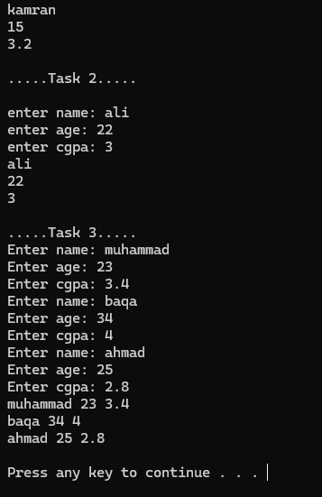

PART-B: Core Tasks (1 Hour)

Task 4: Passing Structs to Functions
Write the following functions:
1. Student inputStudent() – Reads student details and returns a struct.
2. void printStudent(Student s) – Prints the struct.
In main(), call these functions to input a student and display the result.

SOLUTION:
#include<iostream>
using namespace std;

struct student {
string name;
int age;
float cgpa;
};
student input_student(){
student std;
cout<<"Enter name: ";
cin>>std.name;
cout<<"Enter age: ";
cin>>std.age;
cout<<"Enter CGPA: ";
cin>>std.cgpa;
return std;
}
void print_student(student std){
cout<<endl;
cout<<"Name: "<<std.name<<endl;
cout<<"Age: "<<std.age<<endl;
cout<<"CGPA: "<<std.cgpa<<endl;
}
int main(){
student x=input_student();
print_student(x);
cout<<endl;
system("PAUSE");
return 0;}

OUTPUT:
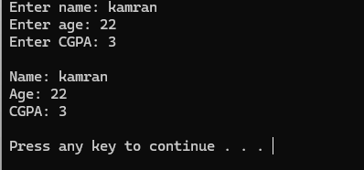

Task 5: Searching in Struct Array
Create an array of 5 Student objects.
Write a function int searchByName(Student arr[], int n, string key) that:
• Searches the array by name
• Returns the index if found, or -1 if not found
Display appropriate messages in main().

SOLUTION:
#include<iostream>
using namespace std;
struct student{
string name;
int age;
float cgpa;
};

int search_by_name(student arr[2],string key){
bool found = false;
int ind = -3;
for(int i=0;i<2;i++){
if(arr[i].name == key){
found=true;
ind = i;
}
}
if(found){
return ind;
}
else
return -1;
}
int main(){
student array[2];
array[0].name = "kamran";
array[0].age = 18;
array[0].cgpa = 3.2;

array[1].name = "ali";
array[1].age = 22;
array[1].cgpa = 3.8;

string n;
cout<<"Enter name to search: ";
cin>>n;
int x;
x= search_by_name(array,n);

if(x==-1){
cout<<"Name not found";
}
else
cout<<"Name found at "<<x<<" index";
cout<<endl;
cout<<endl;
system("PAUSE");
return 0;
}

OUTPUT:
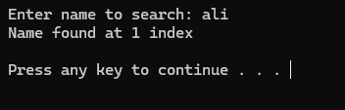

Task 6: Find Student with Highest CGPA
Write a function Student findTopper(Student arr[], int n) that returns the student with the highest CGPA.
Display the topper’s name and CGPA.

SOLUTION:
#include<iostream>
using namespace std;
struct student{
string name;
int age;
float cgpa;
};

int search_by_name(student arr[4]){
int ind = 0;
float high = 0.0;
for(int i=0;i<=3;i++){
if(arr[i].cgpa > high){
ind = i;
high=arr[i].cgpa;
}
}
return ind;
}
void print_topper(student arr[4],int a){
cout<<"Name of topper: "<<arr[a].name<<endl;
cout<<"CGPA: "<<arr[a].cgpa;
}

int main(){
student array[4];
array[0].name = "kamran";
array[0].age = 18;
array[0].cgpa = 3.9;

array[1].name = "ali";
array[1].age = 22;
array[1].cgpa = 3.7;

array[2].name = "khan";
array[2].age = 22;
array[2].cgpa = 4;

array[3].name = "muhammad";
array[3].age = 22;
array[3].cgpa = 4.6;

int x;
x= search_by_name(array);

print_topper(array,x);
cout<<endl;
system("PAUSE");
return 0;
}

OUTPUT:

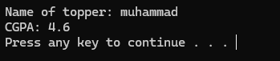

PART-C: Final Application (1 Hour 15 Minutes)

Task 7: Mini Student Database System (Menu-Driven Program)
Develop a complete menu-driven application using structs. The Student struct should contain:
• Roll number
• Name
• CGPA
The program should show the following menu:
1. Add Student
2. Display All Students
3. Search Student by Roll Number
4. Update CGPA
5. Exit
Details:
• Add Student → Append a new student to the array
• Display All → Print all stored students
• Search → Return index or show 'Not found'
• Update CGPA → Modify CGPA of an existing student

SOLUTION:
#include<iostream>
using namespace std;
struct student{
string name;
int age;
float cgpa;
};
int c = 4;
void add_student(student array[20]){
cout<<"Enter name of student: ";
cin>>array[c].name;
cout<<"Enter age of student: ";
cin>>array[c].age;
cout<<"Enter cgpa of student: ";
cin>>array[c].cgpa;
cout<<"Student added..."<<endl;
c++;
}

void print_student(student arr[20], int size){
for(int i=0; i<size; i++){
cout<<"\nName: "<<arr[i].name<<endl;
cout<<"Age: "<<arr[i].age<<endl;
cout<<"CGPA: "<<arr[i].cgpa<<endl;
}
}

int search_student(student arr[20], string key){
int ind = -1;
for(int i=0; i<20; i++){
if(arr[i].name == key){
ind = i;
}
}
return ind;

}

void update_cgpa(student arr[20], string key){
int ind = -1;
float new_cgpa;
bool updated = false;
for(int i=0; i<20; i++){
if(arr[i].name == key){
cout<<"Enter new cgpa: ";
cin>>new_cgpa;
arr[i].cgpa = new_cgpa;
cout<<"gpa updated...";
updated = true;
break;
}
if(!updated){
cout<<"student not found";
}

}
}

}
int main(){
student array[20]= {{"kamran", 18, 3.9} , {"ali", 35, 3.7} ,
{"khan", 12, 4}, {"muhammad", 22, 4.6}};
while(true){

cout<<"\n\n\tMENU"<<endl<<endl;
cout<<"1. Add new student"<<endl;
cout<<"2. Print all students"<<endl;
cout<<"3. Search student by name"<<endl;
cout<<"4. update CPGA"<<endl;
cout<<"5. EXIT"<<endl;

int choice;
cout<<endl<<"Enter your choice: ";
cin>>choice;

if(choice == 1){
add_student(array);
cout<<endl;
}
else if(choice ==2){
print_student(array, c);
}
else if(choice ==3){
string key1;
cout<<endl<<"Enter name of student to search: ";
cin>>key1;

int x = search_student(array,key1);
if(x==-1){
cout<<"Student not found";
}
else
cout<<"student found at "<< x<<" index";
}
else if(choice ==4){
string key2;
cout<<endl<<"Enter name of student: ";
cin>>key2;
update_cgpa(array,key2);
}
else if(choice ==5){
cout<<"T H A N K Y O U !";
break;
}

}

cout<<endl;
system("PAUSE");
return 0;
}

OUTPUT:

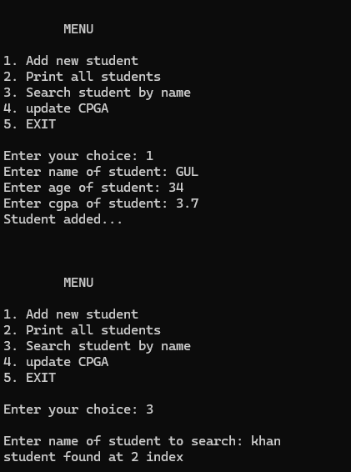

BONUS TASK (Optional)
Sort the students by CGPA using bubble sort and print the sorted list.
SOLUTION:
#include<iostream>
using namespace std;
struct student{
string name;
int age;
float cgpa;
};
int c = 4;
void print_student(student arr[20], int size){
for(int i=0; i<size; i++){
cout<<"\nName: "<<arr[i].name<<endl;
cout<<"Age: "<<arr[i].age<<endl;
cout<<"CGPA: "<<arr[i].cgpa<<endl;
}
}

void bubble_sort(student arr[20]){
for (int i=c-1;i>=0;i--){
for (int j=0;j<i;j++){
if (arr[j].cgpa > arr[j+1].cgpa){
student temp = arr[j];
arr[j] = arr[j+1];
arr[j+1] = temp;
}
}
}

}
int main(){
student array[20]= {{"kamran", 18, 3.9} , {"ali", 35, 3.7} ,
{"khan", 12, 4}, {"muhammad", 22, 4.6}};

bubble_sort(array);
print_student(array,c);
cout<<endl;
cout<<"...Sorted by CGPA...";

cout<<endl;
system("PAUSE");
return 0;
}

OUTPUT:

